**Appendix S1—Additional Figures for “Effects of Native Bryophytes on Exotic Grass Invasion Across an Environmental Gradient”**

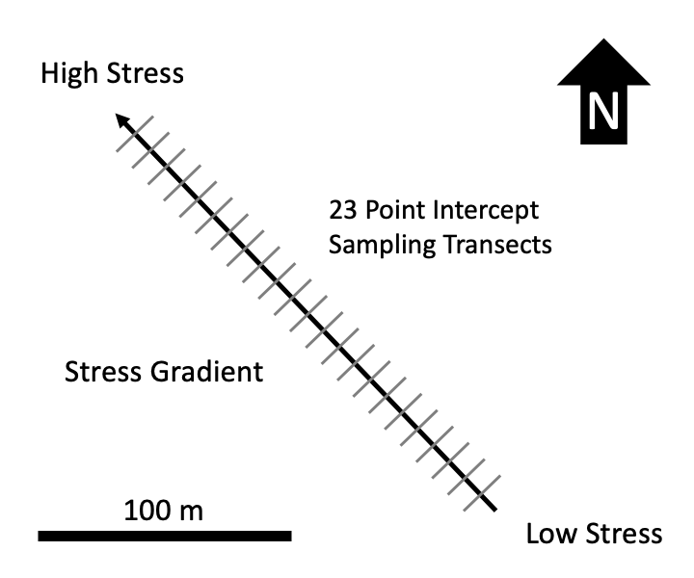

**Figure S1** – Schematic of environmental gradient and observational study design. 23 20 m long transects were sampled along the length of the roughly 220 m long environmental gradient, running from sheltered SE end (lower wind speed and finer sand) to the more exposed NW end (higher wind speed and coarser sand). Experimental blocks for the moss removal experiment were located on the same gradient.

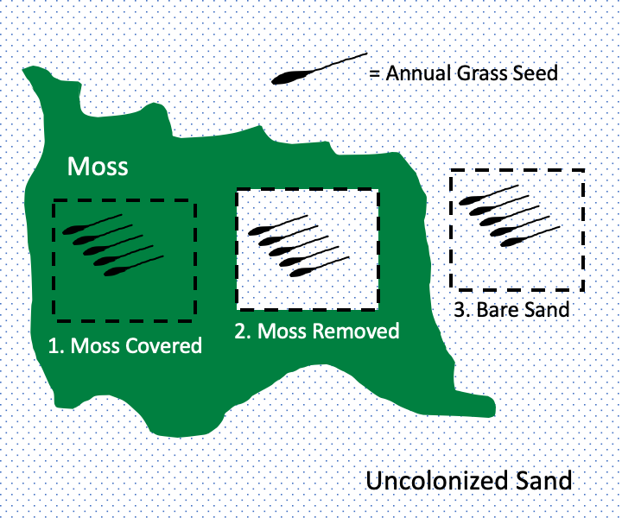

**Figure S2** – One experimental block in the moss removal experiment. Nine experimental blocks were located at the SE end of the gradient and nine located at the NW end of the gradient (see Appendix S1: Fig. S1). Each block was centered on a large moss mat moss and consisted of three experimental patches—a natural moss patch, a patch with moss removed and a bare sand patch outside of moss. Five seeds of exotic annual grasses were planted in each patch. Separate blocks were used for *Vulpia* and *Bromus*.



**Figure S3** – Frequency of exotic vascular plants inside and outside of moss patches across the environmental gradient. Y-axis gives proportion of plants rooted within 1 cm of sampling point. Symbol size is scaled to indicate the number of samples within each habitat at each position along the gradient—larger symbols indicate larger sample size. Lines and shaded areas show back-transformed means plus or minus standard error from a binomial model.



**Figure S4** – Frequency of native vascular plants inside and outside of moss patches across the environmental gradient. Y-axis shows proportion of plants rooted within 1 cm of sampling point. Symbol size is scaled to indicate the number of samples within each habitat at each position along the gradient—larger symbols indicate larger sample size. Lines and shaded areas show back-transformed means plus or minus standard error from a binomial model.



**Figure S5** – Frequency of exotic annual grasses (both *Bromus* and *Vulpia*) inside and outside of moss patches across the environmental gradient. Y-axis shows proportion of plants rooted within 1 cm of sampling point. Symbol size is scaled to indicate the number of samples within each habitat at each position along the gradient—larger symbols indicate larger sample size. Lines and shaded areas show back-transformed means plus or minus standard error from a binomial model.